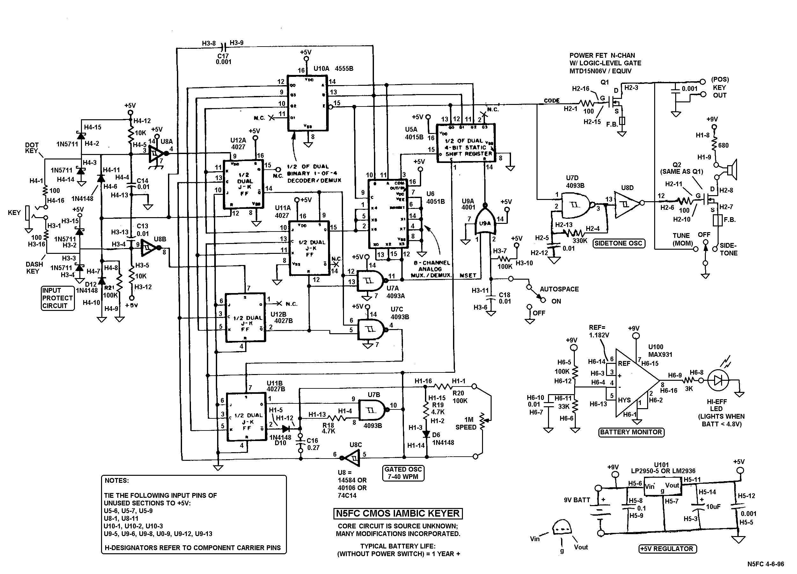
keyer_schem.doc / 1-21-00 / mdn

